# 2016

**Official Atlanta Caribbean Carnival**

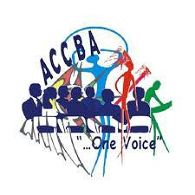

Sponsorship Information

**Saturday May 28th, 2016**

**Historic 4th Ward Park**

**680 Dallas St**

**Atlanta, GA 30308**

#### [www.atlantacarnival.org](http://www.atlantacarnival.org/)

|  |  |
| --- | --- |
|  |  |
|  |  |

Economic Impact **of the Official Atlanta Caribbean Carnival**

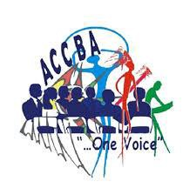

###### The Official Atlanta Carnival mission is to promote a broader understanding and deeper appreciation for Caribbean culture by seeking the interest of Atlanta Caribbean carnival groups and using the Atlanta Caribbean Carnival as a vehicle for the promotion of Caribbean culture among the broader Metro Atlanta community. Atlanta has over 443,775 people of whom 20,527 are estimated to be Caribbean or of Caribbean heritage. Over 9,687,653 people reside in the State of Georgia. Additionally, the City of Atlanta drew over 40.4 million visitors last year. This provides an excellent platform for advertisement and marketing.

*These figures based on Economic Study by US Census Bureau and D.K. Shifflet and Associates Study for visitor estimate.

The 28th Annual Official Atlanta Caribbean Carnival, every year provides unique sponsorship and marketing opportunities for businesses and organizations to reach the fast growing Caribbean population of Atlanta Georgia through various Cultural Extravaganzas.

Atlanta is also home to a large population of people from the world that are lovers of Carnival and actively participate in the festivities. These festivities are broadcasted through various media: radio, television (including news coverage), newspapers, etc. This year, millions of television viewers will have the opportunity, once again, to celebrate Carnival in Atlanta where “Carnival is Mas and Music” - Celebrating 28 years of Caribbean Carnival in Atlanta”.

The Official Atlanta Caribbean Carnival is seeking a sponsorship commitment in support of Carnival 2016. The event will be held on Saturday, May 28th, 2016. The Official Atlanta Caribbean Carnival started in 1987 when a diverse group representing several Caribbean islands came together to familiarize the Metro Atlanta community with Caribbean culture through the presentation of a West Indian style Carnival. The first Caribbean Carnival in Atlanta was held in 1988 and became the official kick-off of the U.S. carnival season and brought thousands of visitors to metro Atlanta for Memorial Day weekend. The events surrounding Atlanta Carnival became a mainstay on the calendars of West Indians from all over the world. This year's festivities promise to be even more exciting than ever. The Parade of Bands and the performances at the Festival Village are guaranteed to take the Atlanta Carnival to the next level.

Sponsorship of this, largest family oriented Caribbean event in the State of Georgia for the past 28 years, would offer your company a unique opportunity to attach its brand name and logo to an internationally-renowned festival. This richly diverse cultural event brought over 25,500 patrons, including visitors from 39 different states and other Countries to Atlanta, Georgia in 2014. About ninety percent (90%) of those visitors utilized air transportation, stayed in area hotels, dined in restaurants, shopped in local Malls and boutiques, rented cars and utilized all other available transportation services.

An integrated marketing campaign will be implemented to promote the major and auxiliary sanctioned events of Carnival 2016. The marketing plan includes a major media blitz through intended partnerships with major national, international and local television and radio, and the internet, including digital, mobile and social media services.

The Official Atlanta Caribbean Carnival has grown since its inception, with anticipated attendance this year in excess of 30,000 patrons. As the festival has diversified, crossing over into the multi-ethnic cultures of Atlanta, Georgia, it has become an ideal medium for corporations to generate exposure for their products and services. Partnering with the Official Atlanta Caribbean Carnival provides an awesome opportunity to increase awareness to a targeted audience of progressive and upwardly mobile and receptive consumers.

The Official Atlanta Caribbean Carnival would be happy to meet with you to further discuss your participation. Please contact Patricia Henry 404.519.6120 | Karen David 770.837.6375 | or email [info.atlantacarnival@gmail.com.](mailto:info@atlantacarnival.org)

***HISTORY OF ATLANTA CARIBBEAN CARNIVAL AND ACCBA***



In 1987, a diverse group representing several Caribbean islands came together to familiarize the metro Atlanta community with Caribbean culture through the presentation of a West Indian style carnival. The first Caribbean Carnival in Atlanta was held in 1988 and became the official kick-off of the

U.S. carnival season and brought thousands of visitors to metro Atlanta for Memorial Day weekend. The events surrounding Atlanta Carnival became a mainstay on the calendars of West Indians from all over the world.

In 2003, several leaders of local masquerade bands came together to form the Atlanta Caribbean Carnival Bandleaders Association (ACCBA). The group was formed to represent the interests of the masquerade bands in the planning of the Atlanta Caribbean Carnival. The goal of the group was to serve as an advocate to represent the needs of the bandleaders and to offer mentoring and aid to those taking part in the art form of producing carnival costumes.

Since 2005, ACCBA has produced the annual Atlanta Caribbean Carnival. The group has brought thousands of patrons to venues throughout Metro Atlanta. ACCBA is dedicated to producing events that helps increase awareness of the various Caribbean art forms and to working within the community to promote diversity and art education. This year's festivities promise to be even more exciting than ever. The Parade of Bands and the performances at the Festival Village are guaranteed to take the Atlanta Carnival to the next level.

Thank you in advance for your help and support in making Atlanta Caribbean Carnival a huge success! We know that branding and marketing your company is a priority and we will work with you to ensure your product and or services gets the highest level of exposure that we can provide based on your level of participation!

**2015**

**Carnival Events**

###### Saturday, May 14, 2016

###### Children’s Carnival / Pan in the Park

###### 4pm - 8pm

**Historic 4th Ward Park**

680 Dallas St

Atlanta, GA 30308

**Thursday, May 26, 2016**

**International Fashion Forum**

**7pm – 11pm**

**Marriott Marquis**

**265 Peachtree Center**

**Atlanta, GA 30303**

**Friday, May 27, 2016**

**4th Outdoor Jouvert 10pm - 4am**

**Venue TBA**

###### Official 27th Annual Atlanta Caribbean Carnival

**Parade & Festival Villa**

**Saturday May 28th , 2016**

**Atlanta Caribbean Carnival**

**10am-10pm**

**Parade of Bands**

**12pm – 3pmlage:**

**Historic 4th Ward Park**

**680 Dallas St**

**Atlanta, GA 30308**

###### Cooler Fete

[www.atlantacarnival.org](http://www.atlantacarnival.org/)



**ATLANTA CARIBBEAN CHILDREN'S CARNIVAL**

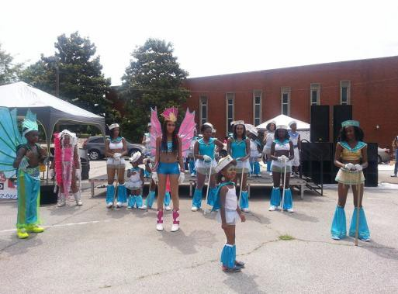

**Saturday, May 14th, 2016**

The Atlanta Children’s Carnival provides children with the joy of unearthing the treasures of the Caribbean heritage by involving the community in the process in order to recognize and respect the rich diversity of world cultures.

**4th Annual Outdoor J’ouvert**

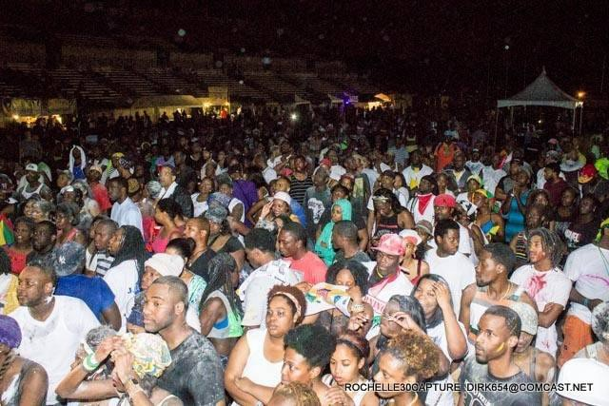

**Friday, May 27th, 2016**

A J’ouvert is an outdoor party that attracts people from all over, young and old out to dance and have a good time the night before carnival.

Official 28th Annual Atlanta Caribbean Carnival Parade & Festival Village

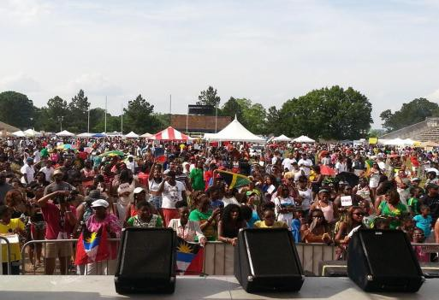

**Saturday May 28th, 2016**

##### The day’s events will start with the colorful Parade of Bands through the park. The festivities will culminate with the highlight of our festival - the “Village”. In the “Village”, there will be a variety of events featuring music, dance, calypsonians, steelpan bands and other art forms indigenous

to the Caribbean. This is your opportunity to showcase your merchandise, as the popular “Village” includes the delectable cuisine of the Caribbean, United States, and other nations

as well as arts and craft vendors displaying goods that are popular in the Caribbean.

**We invite you to consider sponsoring our Spectacular Events! Choosing to sponsor our event will result in optimizing your demographic outreach by incorporating your company name and information in advertisements on a large scale in real time on social media networks like our website, Twitter, Facebook main page and group pages! Have traffic redirected to your company’s website through links and posts that will be put on our website that receives over 3.5 million hits before our event on May 28th, 2016. Thank you!**

**\*Note: pictures from 2014 events**

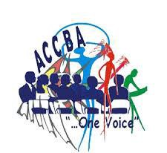

|  |  |  |  |  |  |  |  |  |  |
| --- | --- | --- | --- | --- | --- | --- | --- | --- | --- |
|  | **Platinum** | | **Gold** | | **Silver** | | **Bronze** | | **In-**  **Kind** |
| **PRINT** | $10,000 | | **$5,000** | | **$2,000** | | **$1,000** | | **-** |
|  | | | | | | | | | |
| Sponsor logo on selected print advertising and collateral  materials, including magazine, newspapers and trade publications throughout the United States, Canada, and the Caribbean | √ | | √ | | √ | | √ | | √ |
| Color advertisement in the official souvenir e-book | √ | | √ | | √ | | √ | | √ |
| Logo inclusion on “Calendar of Events” promotional material | √ | | √ | | √ | | √ | | √ |
| Logo inclusion on all invitations | √ | | √ | | √ | | √ | | √ |
| **ELECTRONIC, RADIO, TELEVISION** | | | | | | | | | |
| Name inclusion in all major mass media PSAs and commercials  (radio and television) Units-: 60 sec., 30 sec., and 15 sec | √ | √ | | √ | |  | |  | |
| Name inclusion in 4-week radio buys on Latin, Caribbean,  Urban, and crossover stations | √ | √ | | √ | |  | |  | |
| **SIGNAGE** | | | | | | | | | |
| Logo on all flyers and posters | √ | √ | | √ | | √ | | √ | |
| Sponsor provided Outdoor signage at the entrance to all events | √ | √ | | √ | | √ | | √ | |
| Sponsor-supplied banner on main Entertainment Stage at each  event | √ | √ | |  | |  | |  | |
| **ON-SITE PROMOTION – Festival Village** | | | | | | | | | |
| Corporate (10 x 10) booths in prime location at venue, for  sampling and/or information dissemination, | √ | √ | | √ | |  | |  | |
| Sponsor-supplied banners to be displayed at Event Venue | √ | √ | | √ | | √ | |  | |
| Periodic stage announcements by event host | √ | √ | | √ | | √ | | √ | |
| Company product giveaways at all events for sampling and/or  information dissemination. | √ | √ | | √ | | √ | | √ | |
| **WORLD WIDE WEB** | | | | | | | | | |
| 5,000+ e-mails will be generated each month with sponsor name  and logo | √ | √ | | √ | | √ | | √ | |
| Sponsor’s name and logo on atlantacarnival.org website | √ | √ | | √ | | √ | | √ | |
| Hyperlink to sponsor’s corporate site | √ | √ | | √ | | √ | | √ | |
| Banner advertisement on website | √ | √ | |  | |  | |  | |
| **HOSPITALITY** | | | | | | | | | |
| 10 VIP All-Access passes for Festival Village May 23rd, 2015  including VIP Hospitality Booth (catering and bar provided). | √ |  | |  | |  | |  | |
| 5 VIP All-Access passes for Festival Village May 23rd, 2015  including VIP Hospitality Booth (catering and bar provided). |  | √ | |  | |  | |  | |
| 2 VIP All-Access passes for Festival Village May 23rd, 2015  including VIP Hospitality Booth (catering and bar provided). |  |  | | √ | |  | |  | |
| 1 VIP All-Access pass for Festival Village May 23rd, 2015  including VIP Hospitality Booth (catering and bar provided). |  |  | |  | | √ | |  | |

### Atlanta Caribbean Carnival Bandleaders Association, Inc SPONSORSHIP COMMITMENT FORM



###### Company/Individual Name:

**Representative:**

**Title:**

**Address:**

**Suite:**

**City: Zip:**

**Phone: ( )**

**Fax: ( )**

**E-mail:**

**Website:**

**Referred by:**

**PLEASE INDICATE YOUR LEVEL OF PARTICIPATION**

|  |  |
| --- | --- |
| **PLATINUM Sponsor** | **$10,000.00** |
| **GOLD Sponsor** | **$ 5,000.00** |
| **SILVER Sponsor** | **$ 2,000.00** |
| **BRONZE Sponsor** | **$ 1,000.00** |
| **IN-KIND Sponsor** | **Item donations and prizes (minimum 150 pieces)** |

**# of items Type of Item**

**Payment Enclosed: $**

**Make Check payable to:**

**Atlanta Caribbean Carnival Bandleaders Association, Inc**

**P.O Box 742384**

**Riverdale, GA 3027**

**To meet print and media deadlines, sponsorship deadline is March 5th, 2016.**

**Note:**

1. **If camera artwork does not accompany this form, please inform us of the date we can expect it.**
2. **If you wish to have your artwork returned, check here .**